
Better with Age Guide: Digital Sharing Kit
Grantmakers In Aging (GIA) offers this digital sharing kit to accompany our new publication, Better with Age: A Guide to Funding in a Longevity Society.
The Guide is designed for all kinds of funders. It explores how investing in aging can add innovation and impact to any funding strategy; lays out key issues and data; and recommends specific opportunities for program investment, expansion, or adaptation.
In this kit, you’ll find social media posts for any organization and a few tailored posts for organizations that are featured in the Guide, graphics to accompany the social posts, newsletter language, and a one-page overview of the Guide. You are welcome to adapt the language.
You can also find these sharing resources online here.
Thank you for helping us spread the word by sharing the Guide with your networks.

General social media posts (accompanying graphics begin on page 4)
Please tag us when you post!
LinkedIn www.linkedin.com/company/grantmakers-in-aging-gia/
Facebook www.facebook.com/GrantmakersInAging/
X x.com/GIAging
LinkedIn or Facebook 1 (choice of graphics #1, #2, #4, #5)
Aging cuts across many issues.
Explore how investments that support older people can add impact to any funding portfolio, in Better with Age: A Guide to Funding in a Longevity Society - a new resource from Grantmakers In Aging. Plus: key aging data and Program Snapshots that show how aging intersects with, well, almost everything. Find it at www.GIAging.org/better-with-age
LinkedIn or Facebook 2 (Choice of graphic)
Caring doesn’t come with an expiration date.
Whether you fund in healthcare, social connection, mental health, biomedical research, disaster response and resilience, or LGBTQ+, racial, ethnic, gender, rural, or civil rights issues, applying an aging lens can increase your impact.
Find out how in Better with Age: A Guide to Funding in a Longevity Society from Grantmakers In Aging. Download at www.GIAging.org/better-with-age
X 1 (choice of graphics #2, #3, #4)
Whether you fund healthcare, mental health, social connection, civil rights, LGBTQ, racial, gender, children, or rural issues, increase your impact by adding an aging lens: new @GIAging Better with Age Guide at www.GIAging.org/better-with-age
X 2 (choice of graphics #1, #2, #3, #4)
We’re all getting older every day. That makes aging a cross-cutting issue for many funders. Find powerful intersections with your work in the new Better with Age Guide from @GIAging at www.GIAging.org/better-with-age

Additional posts for funders and nonprofits mentioned in the Guide
NONPROFIT POST 1 – for LinkedIn or Facebook (choice of graphics #2, #5)
Older people’s contributions are a tremendous resource. We are delighted our work to [PROJECT OBJECTIVE] is featured in Better with Age - a new funding guide from Grantmakers In Aging. www.GIAging.org/better-with-age
NONPROFIT POST 2 – for LinkedIn or Facebook (choice of graphics #2, #3, #4)
How do you make a great idea even better? Share it with more people. We are delighted that our work to [PROJECT OBJECTIVE] is featured in Better with Age, a new funding guide from Grantmakers In Aging. www.GIAging.org/better-with-age
NONPROFIT POST 3 – for X (choice of graphics #2, #3, #5)
We are delighted that our work to [PROJECT OBJECTIVE] is featured in a new resource from @GIAging - the Better with Age Guide www.GIAging.org/better-with-age
FUNDER POST 1 – for LinkedIn or Facebook (choice of graphics #1, #2, #5)
Older people’s ongoing ability to contribute is a tremendous social resource. We are delighted that our nonprofit partner [GRANTEE NAME] and their work to [PROJECT OBJECTIVE] are featured in Better with Age: A Guide to Funding in a Longevity Society - a new resource from Grantmakers In Aging. www.GIAging.org/better-with-age
FUNDER POST 2 – for LinkedIn or Facebook (choice of graphics #1, #3, #4)
What can make a great idea even better? Finding new ways to put it to work. We are delighted that our nonprofit partner [GRANTEE NAME] is featured in a new resource from Grantmakers In Aging - Better with Age: A Guide to Funding in a Longevity Society. www.GIAging.org/better-with-age
FUNDER POST 3 – for X (choice of graphics #1, #2, #4)
We are delighted that our nonprofit partner [GRANTEE NAME] and their work to [PROJECT OBJECTIVE] are featured in Better with Age - a new funder resource from @GIAging www.GIAging.org/better-with-age
Newsletter or website text
When older people are able to continue to contribute as volunteers, employees, mentors, and linchpins of stable families and communities, we all benefit. Yet too few of our systems and policies have kept pace with the new longer lifespans. Better with Age: A Guide to Funding in a Longevity Society from Grantmakers In Aging reviews the funding landscape, offers a demographic portrait of older America, and presents opportunities for funders with many different funding priorities - including child welfare, housing, economic security, rural life, caregiving, and community development - to increase their impact by considering how aging intersects with their investments. Find it at www.GIAging.org/better-with-age.
One-page overview
Download a one-pager for the Better with Age Guide here.
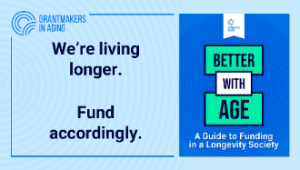
Better with Age Guide - social media graphics
Please download graphics using the links provided for best quality
Graphic #1: Living longer
DOWNLOAD HERE
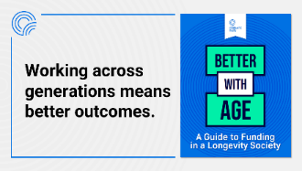
Graphic #2: Across generations
DOWNLOAD HERE
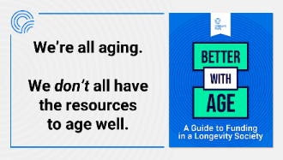
Graphic #3: All aging
DOWNLOAD HERE
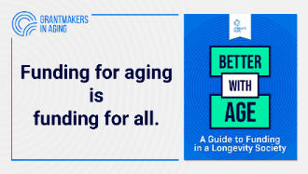
Graphic #4: Funding for all
DOWNLOAD HERE
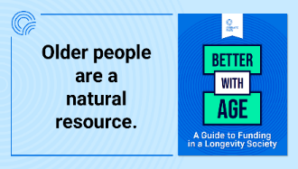
Graphic #5: Natural resource
DOWNLOAD HERE

